**Object Oriented Paradigm – Case Study**

**College Management System**

**Sample Output Screenshots:**

**Login Page:**

**Successful Login:**

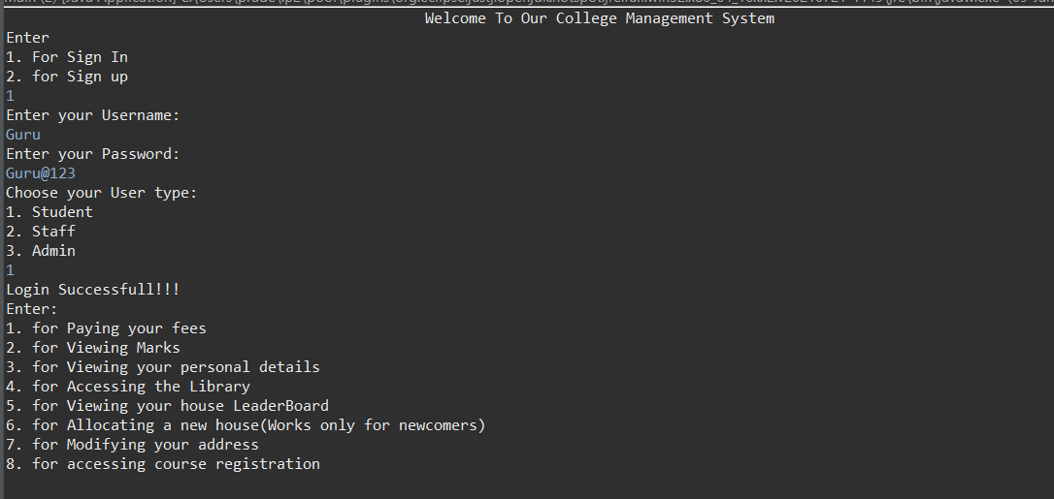

**Failed Login (Invalid Credentials):**

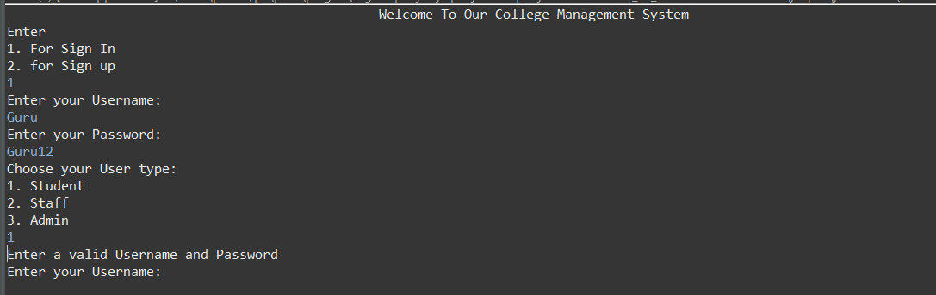

**Sign up:**

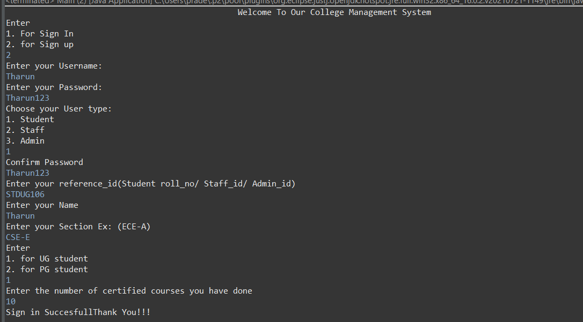

**Student Module:**

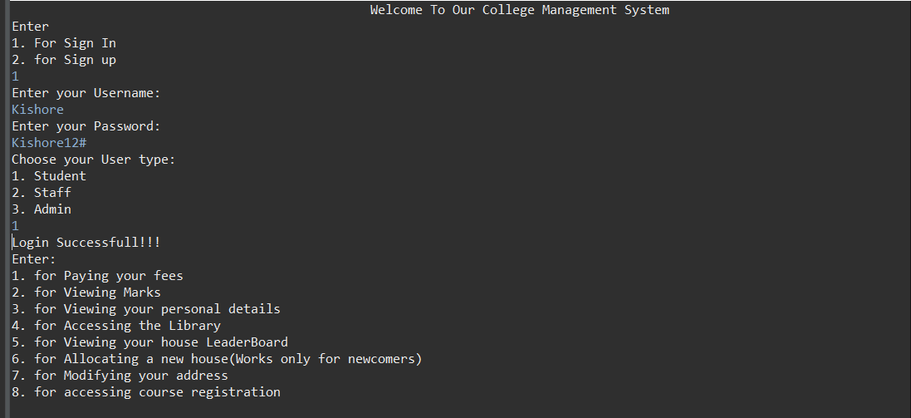

**Staff Module:**

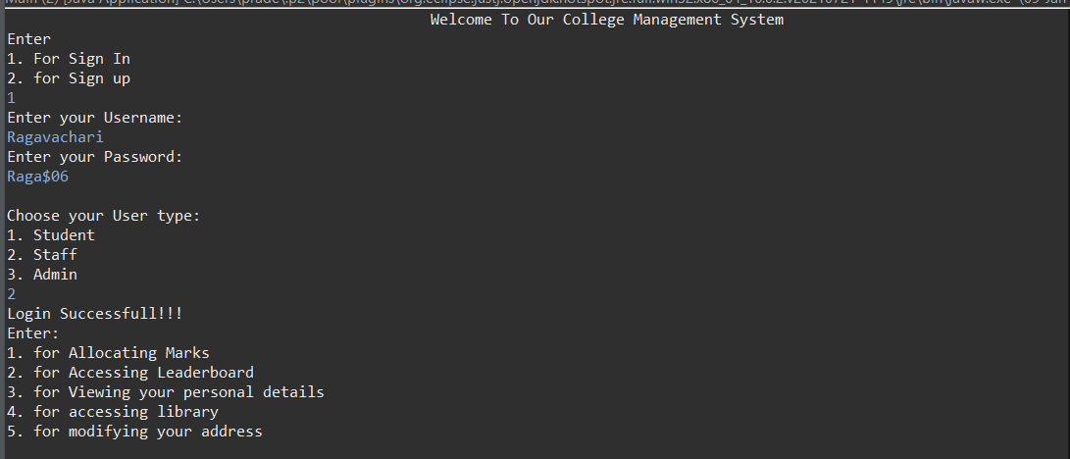

**Admin module:**

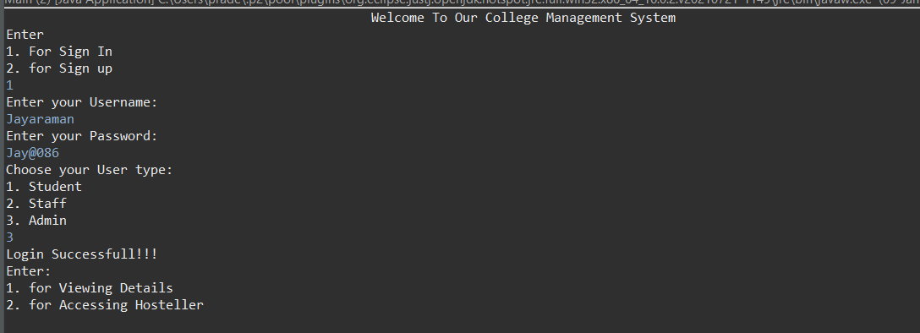

**Functions in Student Module:**

**Fees Payment:**

Output for Student using the module for fees payment:

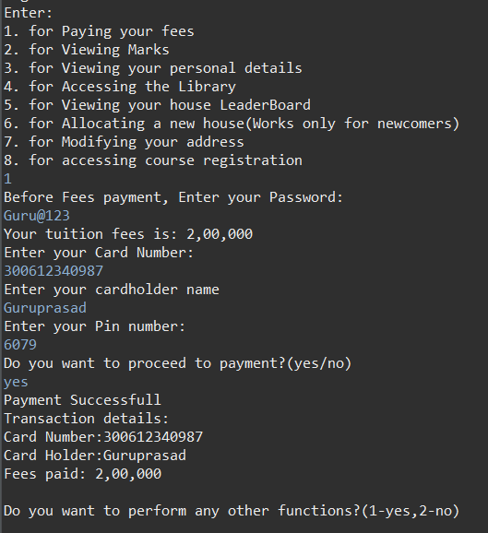

Output for Student who has already paid the fees:

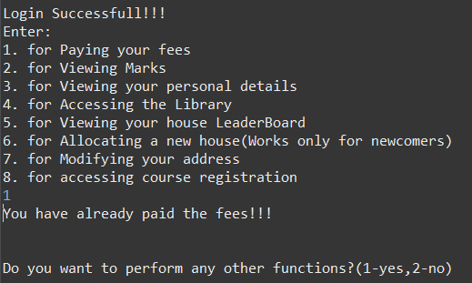

**View marks:**

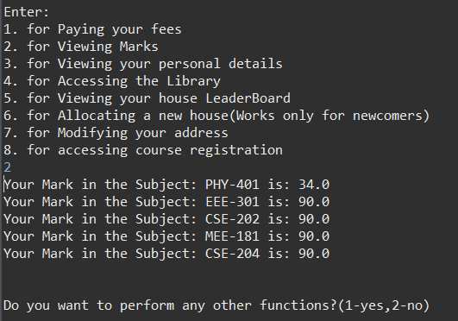

**Viewing Personal Details:**

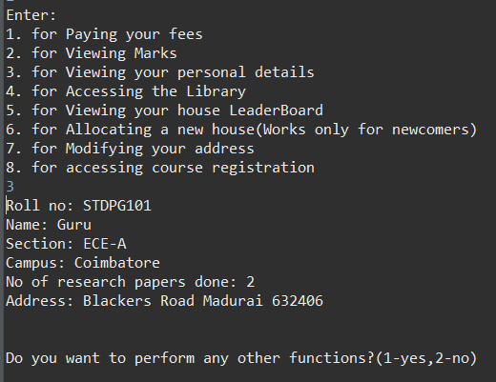

**Accessing the Library:**

Borrowing a Book:

Student who does not have any borrowed book currently:

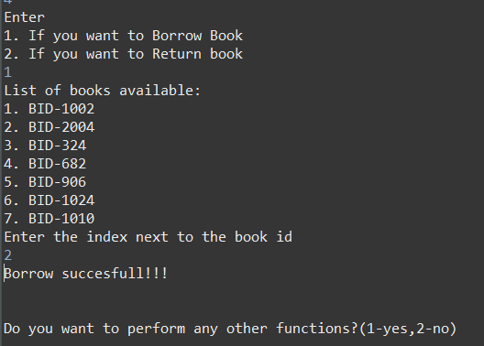

Student who has borrowed a book currently and hasn’t returned:

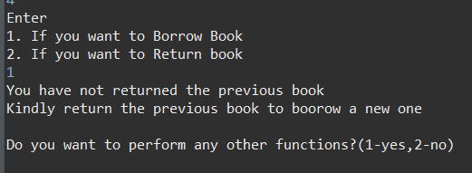

**Returning a Book:**

Student who has borrowed a book:

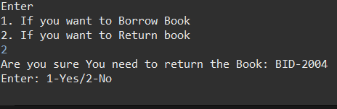

Student who hasn’t borrowed any book:

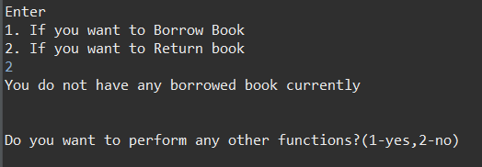

**Viewing Leaderboard:**

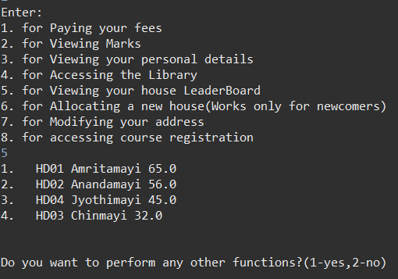

**Allocate House:**

New Student who hasn’t been allotted a house yet:

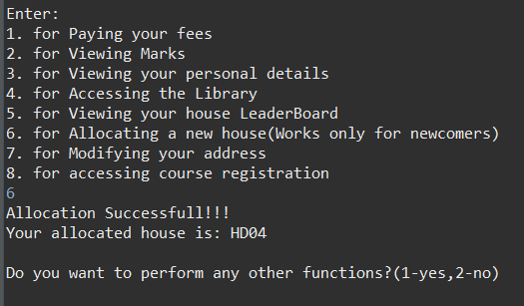

**Student who has been allocated a house already:**

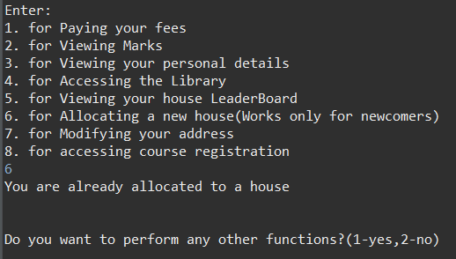

**Modifying Address:**

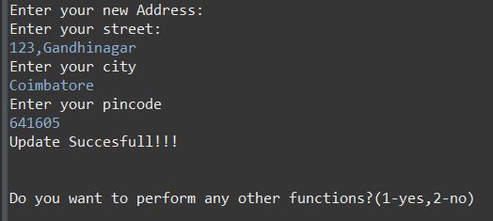

**Accessing Course_registration:**

Removing previously registered courses:

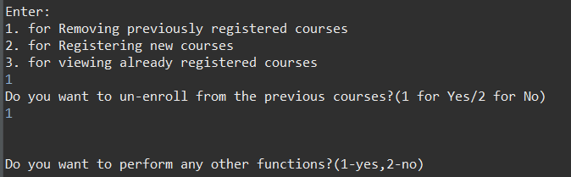

Registering new courses:

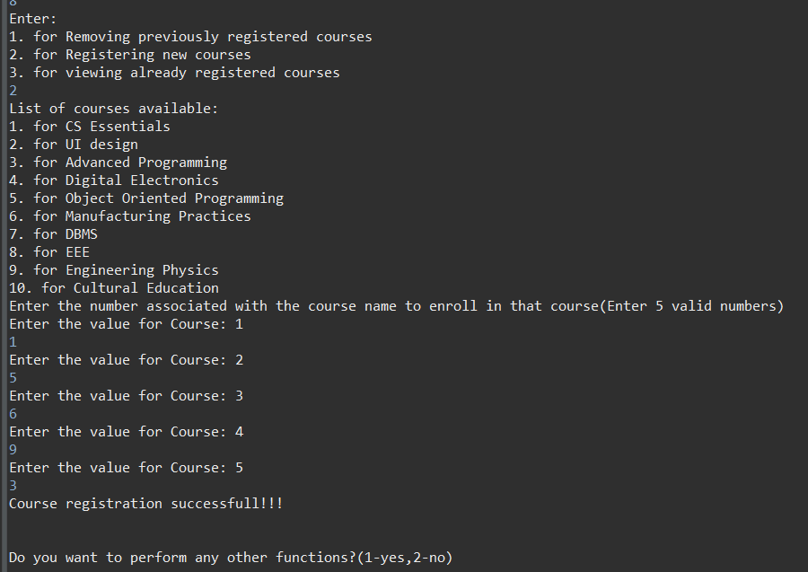

If the Student hasn’t unenrolled from previous courses:

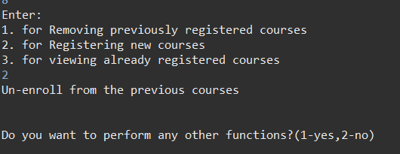

**Viewing Currently Registering courses:**

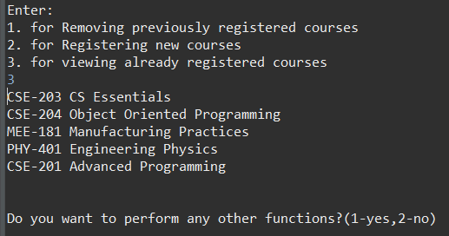

**Functions in Staff Module:**

**Allocate marks:**

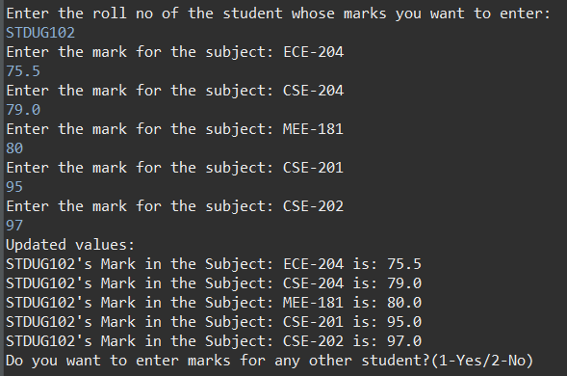

**Accessing Leader Board:**

View Leader Board:

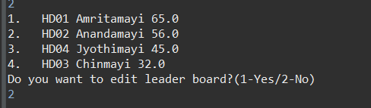

Modify Leader Board:

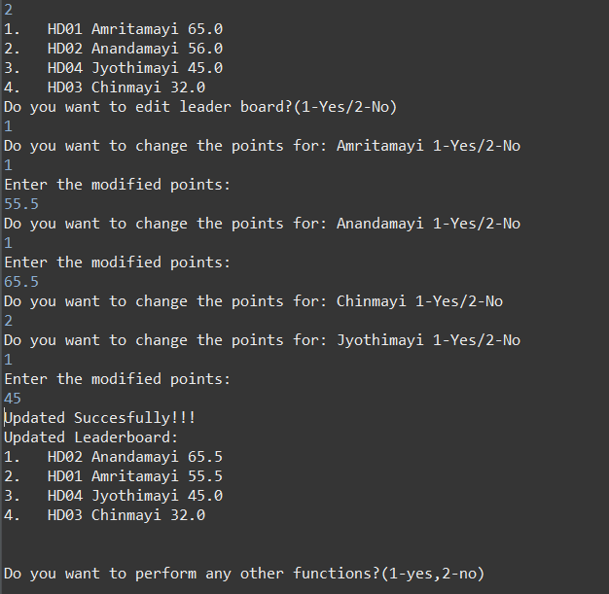

**Viewing Personal Details:**

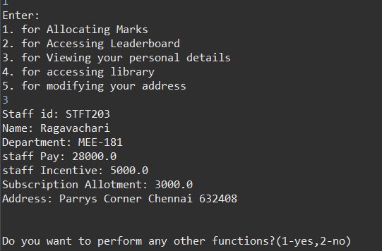

**Accessing Library:**

Borrowing a Book:

Staff who does not have any borrowed book currently:



Staff who has borrowed a book currently and hasn’t returned:



**Returning a Book:**

Staff who has borrowed a book:



Staff who hasn’t borrowed any book:



**Modifying Address:**



**Functions in the Admin module:**

**Viewing All Details:**

Viewing Details of a Student:

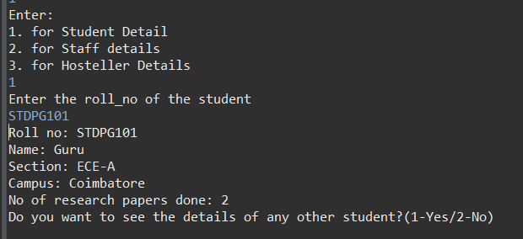

Viewing Details of a Staff:

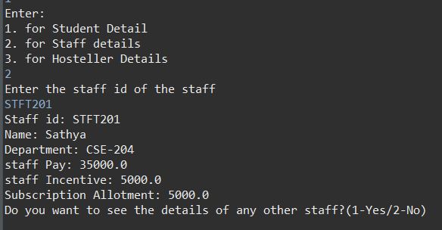

Viewing Details of a Hosteller:

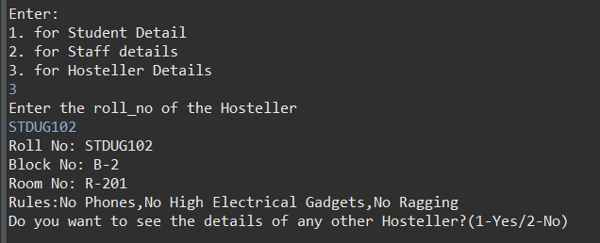

Accessing hosteller:

Checking a Hosteller out:

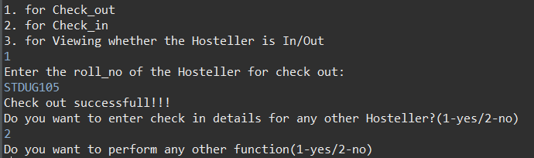

Checking a Hosteller in:

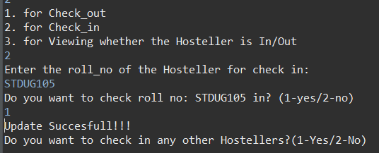

Viewing whether a hosteller is checked in or out:

